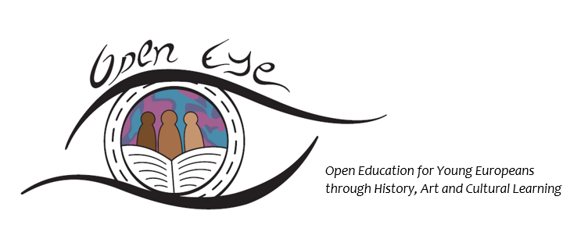
Open Education for Young Europeans through History, Art and Cultural Learning
SYNTHESIS REPORT ON THE LEARNING NEEDS
OF TEACHERS AND SUPPORT STAFF WORKING WITH PUPILS OF A MIGRANT/REFUGEE BACKGROUND IN PRIMARY EDUCATION IN NORWAY, GREECE, SLOVENIA AND ITALY
Compiled by
PRISMA Centre for Development Studies (GR)
With
University of Southeast Norway (NO), Izobrazevalni Center Geoss d.o.o. (SL), Provincia di Livorno (IT), Museum of Greek Children’s Art (GR), Osnovna sola Litija (SL)
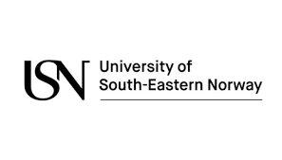
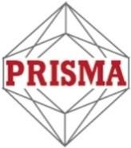
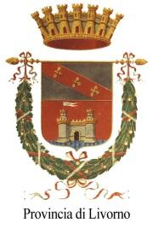
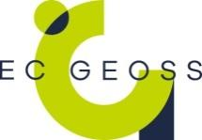

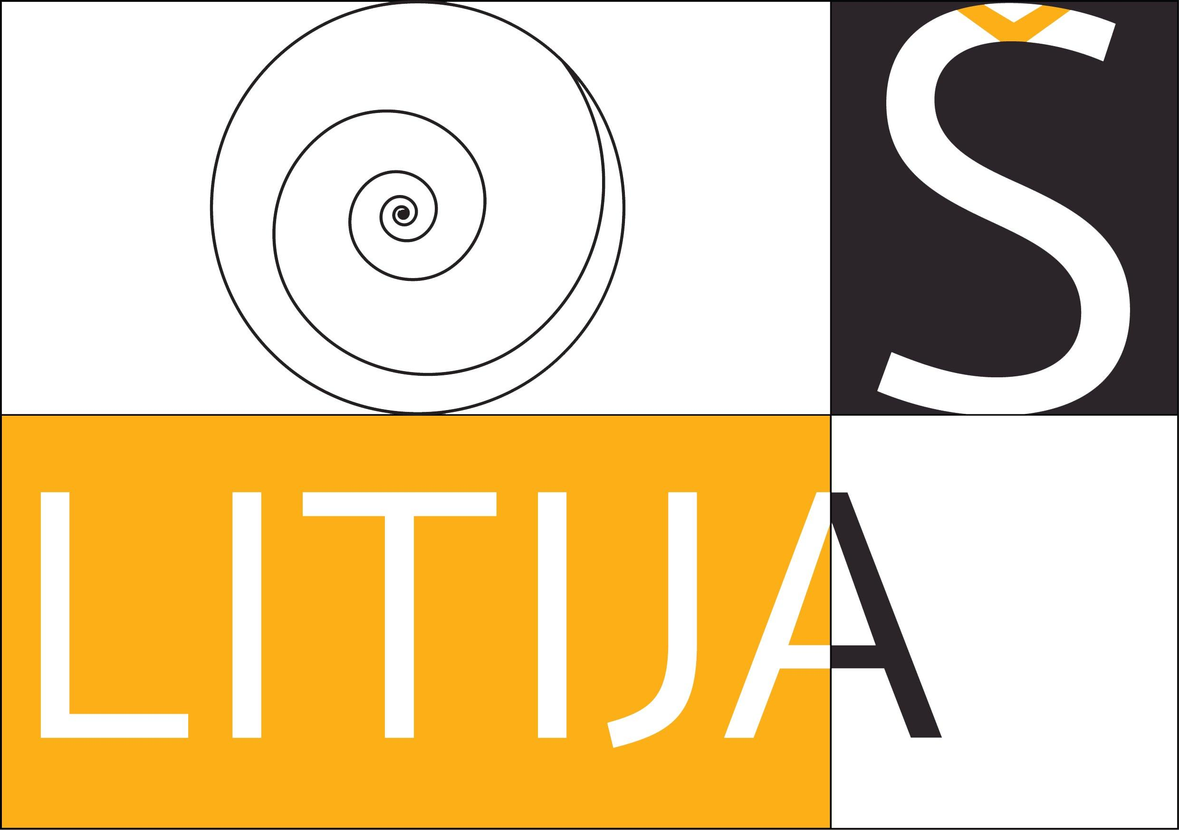
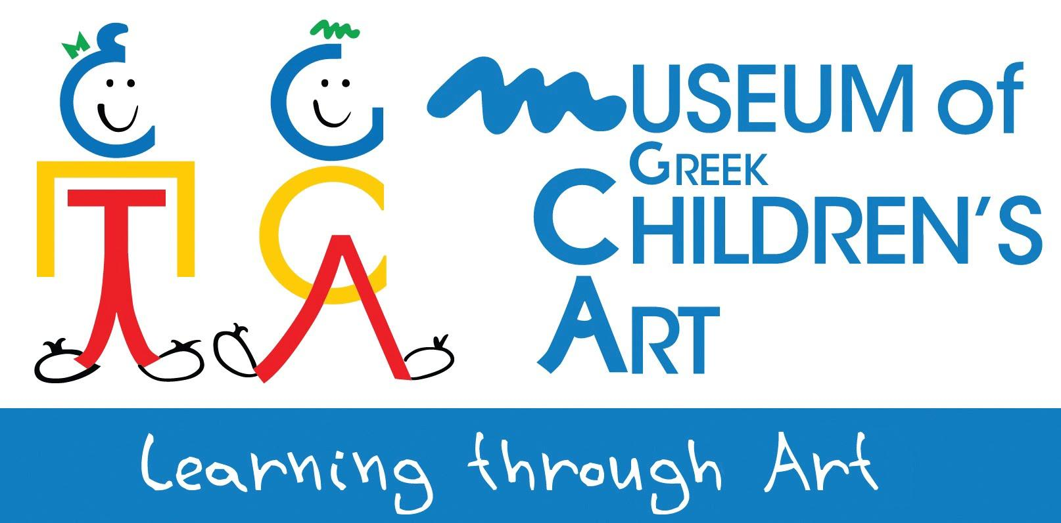

Contents
Introduction 4
National frameworks for integrating children of M/R background in primary education 6
Norway 6
Greece 7
Slovenia 9
Italy 10
Survey and focus groups methodology 11
Findings 13
Online survey findings 13
Profile of survey participants 13
Experience with managing multicultural classes 13
Experience in using cultural expressions in learning activities 14
Benefits of integrating cultural expressions in learning activities 15
Focus groups‘ findings 17
Integration problems 18
Learning priorities 19
Cultural expressions 19
The role of parents and teachers 20
22
Conclusion 23
Appendices 26
National Survey Reports 26
OpenEYE Online Survey Questionnaire 27
OpenEYE focus group questions outline 39

Introduction

The project OpenEYE – “Open Education for Young Europeans through History, Art and Cultural Learning” – is a Strategic Partnerships project implemented in the framework of the Erasmus+ Programme of the European Commission. The project brings together organisations from different remits (academic, research, training, culture, primary school education) from Norway, Greece, Italy and Slovenia with the aim to develop and test a learning methodology and tools based on cultural expressions (music, dance, heritage, painting, storytelling, theatre, etc.) that will be applied in formal and non-formal primary education and help pupils of a migrant/refugee background integrate smoothly in their community.
A core element of the proposed approach is recognizing the role of pupils (both of a migrant/refugee background and native), teachers, parents and organisations active in the field of primary education (e.g. schools, educational authorities, cultural organisations, organisations of the civil society etc.) as stakeholders in the learning and integration process. Cultural expressions are employed because of their inherent properties of easily communicating notions, ideas and learning content in a fun way, as well as expressing feelings, thus providing effective tools in today’s multicultural classrooms for learning and integrating to the school community and beyond.
A first step in the process of developing the learning methodology was the implementation of a survey amongst:
- Representatives of key stakeholder organisations in each of the partner countries regarding their experience and learning needs of themselves as teachers/facilitators as well as their pupils.
- Parents and teachers, regarding their foreseen role in the proposed learning approach and the learning/integration needs of the pupils.
The survey was implemented in Norway, Greece, Slovenia and Italy through an online survey questionnaire that targeted representatives of stakeholder organisations (i.e. teachers, learning facilitators, school leaders etc.) active in the field of primary education regarding their experience and needs in managing multicultural classes, and through focus group meetings that invited parents of pupils with a M/R background and teachers to discuss on their role in the proposed learning approach as well as the pupils’ needs for learning and integration.
The survey results were analysed and the findings per country were compiled in the respective national reports available in the Annex. The present synthesis report aims at bringing together the findings of the survey from all partner countries presented in the national reports, and through a comparative analysis (where this is possible) present the main findings and draw useful conclusions for the design and development of the OpenEYE Learning Methodology.
In order to better understand and interpret the survey findings, it is necessary to draw on the key points of the national framework in place in each of the partner countries for the integration of pupils of a M/R background in primary education. The survey and focus group meetings’ methodology is also presented, followed by the comparative analysis of the survey findings. Finally, the conclusion of the present report summarises the main findings and identifies guidelines for the development of the OpenEYE Learning Methodology.

National frameworks for integrating children of M/R background in primary education

The national frameworks for integrating children of M/R background in primary education that are in place in the 4 different project countries (Norway, Greece, Slovenia and Italy), relate to each country’s background in receiving immigrants and refugees in terms of numbers and profile, and in terms of the country’s role in the immigration process (i.e. entry country to the EU, through country, or final destination country), as well as each country’s integration policy and education policy.

The background of the 4 project countries in receiving immigrants and refugees varies; Greece and Italy have received the greatest numbers of immigrants and refugees from Asian and African countries during the ongoing refugee crisis as entry countries to the EU, while Norway is considered a final destination country for a great number of refugees trying to make their way there and has received a great number of European immigrants, and Slovenia has been receiving mainly immigrants from eastern Europe and former Yugoslavian countries (e.g. Bosnia and Herzegovina). The effort to integrate the children of a M/R background into the primary school system, has placed the partner countries’ educational authorities and schools under considerable stress; in Greece and Italy the need to integrate great numbers of foreign children especially after 2015 was urgent and put considerable stress on the respective educational systems, while in Norway and Slovenia the need to integrate the newcomers to the educational system has put schools under pressure especially in areas with a high concentration of foreign pupils.
The key features of the national framework for integrating pupils of a M/R background into primary education per country are presented below.

Norway

The Norwegian education system follows a purely linguistic approach in defining minority pupils; the children who do not speak Norwegian or Sami (the indigenous people’s language) at home have a right to individual language support in Norwegian at school.
The newly arrived pupils in Norway receive different types of schooling depending on the model chosen by the local municipality in primary and lower secondary education. One of the three models below with different levels of integration into the mainstream schools is usually adopted by municipalities for integrating children of a migrant or refugee background:
- A partly integrated model, in which the pupils of a M/R background are placed in a mainstream class of a school but receive part of their learning in separate groups.
- A non-integrated model in mainstream schools, where the pupils of a M/R background attend introductory classes based in mainstream schools, but most commonly receive all their teaching in a separate class
- A non-integrated model in Reception schools, where pupils of a M/R background receive separate teaching based in a Reception school for up to two years before transferring to mainstream schools.

The main criterion for transferring a pupil of a M/R background to a mainstream school or a mainstream class is his/her competence in Norwegian. This normally takes place after a year in a Reception school or in introductory classes at mainstream schools.
Organisations of the civil society offer complementary learning services and support. The Red Cross, for example, assists pupils with homework support after school hours.

Greece

Based on the core principle that every child has a right and an obligation to go to school, the Greek Ministry for Education formulated a plan in 2016 for the integration of children up to the age of 15 to the national school education system. Daily 4-hour afternoon classes (Reception Classes) on the Greek language, English, Math and cultural activities were introduced in selected public schools, while Education Coordinators were introduced at the refugee camps to assist children in order to attend.
The first year of implementation highlighted a set of weaknesses:
- The teachers in reception classes were not adequately trained to face special challenges like teaching Greek as a foreign language, or work with children who have not been to school for the last 2 (or more) years. Moreover, they did not have access to mentoring or training with regard to managing a multicultural class.
- The complete lack of provision or plan to include the parents in the learning process, led to many children leaving school or not attending regularly. A key obstacle was the lack of interpreters in schools and refugee camps. Moreover, the uncertain situation of the immigrants and refugees regarding their final country of destination and their increased mobility led to many children not attending school regularly and a widespread attitude amongst parents and children of not engaging in the educational process and learning Greek.
- The resistance and reactions by sections of the local communities against the integration of the children of a migrant/refugee background in the local schools in some cases due to xenophobic or racist attitudes.
The Greek Ministry of Education then implemented a different strategy regarding the employment of teachers for the reception classes that started taking place in the mornings (normal school hours); the teachers must participate in training seminars where they can also raise issues and questions regarding their work in the Reception Classes. It was recognized that the difficult task in training teachers is not passing to them the necessary knowledge; it is rather inspiring them and encouraging them to adopt a positive attitude and an open mentality, necessary in a multicultural school environment. Moreover, the Ministry decided to take advantage of the experience of the Multicultural Schools, operating for many years (since 1996) to address the needs of the children of immigrants from eastern Europe, to restructure the learning content to apply in the Reception Classes.
Today the Reception Classes include 2 courses, Reception Class I and Reception Class II:
- Reception Class I is a 1 year course and addresses pupils with minimal or no skills in the Greek language. The pupils follow an intensive Greek language course and take other classes with their regular school class, like Physical Education, Art, Music and Foreign language.
- Reception Class II is a three year course and addresses pupils with moderate skills in the Greek language, who face difficulties following the normal classes. These pupils are then supported in developing their skills in the Greek language or more subjects.
The minimum number of pupils per class in the Reception Classes is 9, and pupils from different grades can attend. The pupils can stop attending following a decision of the teachers mid-year, to focus on their regular class activities. A pupil who has completed the three year course of Reception Class II cannot return to a Reception Class.
In parallel to the processes and tools put in place by the Ministry for Education, NGOs and cultural organisations (e.g. museums) support foreign pupils with their integration in the formal school education through non-formal learning activities that usually take place either in the camps or in the organisations’ facilities, and focus on developing the language skills of the children in Greek as well as psychosocial support.

Slovenia
According to the Primary School Law in Slovenia:
- Children who are foreign citizens or stateless persons and reside in the Republic of Slovenia have the right to compulsory primary education under the same conditions as citizens of the Republic of Slovenia.
- The primary school is to determine which class a child will join when enrolling, on the basis of the submitted evidence of previous education, the child's age and taking into account his/her knowledge of the Slovenian language.
- Pupils of a M/R background can voluntarily take a national knowledge test in their first year of schooling in the 6th or 9th grade.
- Pupils of M/R background may be unrated from individual subjects in their first year of school and advance to the next grade (the only exception is the ninth grade, the final year of primary school, where pupils are assessed in order to advance to secondary education).
Overall, the schools enjoy a great level of autonomy and flexibility in implementing the above guidelines and in general the first two years of school for a child of a M/R background are regarded as adjustment period.
A very recent amendment to the Rules on Norms and Standards for the Implementation of the Primary School Program, in force after September 1st 2020, sets the criteria for the allocation of Slovene language lessons for immigrant pupils. While before the reform the foreign pupils were entitled to additional Slovene language lessons in their first or second year of schooling, which were implemented in an uncoordinated manner in terms of content and form, as well as the teachers in place, depending on the school circumstances, the reform foresees that additional hours of Slovene are only available (compulsory) for foreign pupils enrolling for their first year in a Slovene school or have enrolled mid-term in the previous year, and for pupils who start their second year in a Slovene school (and have completed a full first year) the school at its own discretion proposes different forms of inclusion. A greater number of teaching hours is now dedicated to the assistance teaching, based on the number of pupils of a M/R background enrolling; more than 9 pupils justify a new post for an assistance teacher at the school, while for less pupils the additional hours are financed on the basis of a Minister’s decision. Still, each individual school decides how it will form groups/classes (integrated with native pupils or not). Furthermore, the reform sets for the first time the curriculum for the assistance teaching in Slovene, as well as the qualifications of the teachers to perform them (class teachers or teachers of Slovene).
Finally, a set of projects are currently being implemented, aiming at developing the teachers’ competences and supporting them in managing multicultural / multilingual classes:
- The project “We are only with others” (2016-2021) offers seminars for enhancing theintercultural skills of teachers and educators.
- The project “Intercultural Education Model” adopts a holistic view promoting the active involvement of teachers, children and parents immigrants, other children and parents, local people, local organizations, etc.
- The project “Challenges of intercultural coexistence” (2016-2021) develops a learning methodology based on system support, experience recognition, knowledge verification and evaluation mechanisms, individual action plans, mother tongue learning and intensive initial learning of Slovene, with the emphasis on training teachers in intercultural competences.

Italy
In Italy, it is established by law that “the foreign minors present in the national territory have the right to education regardless of the regularity of their residence permit, in the forms and ways provided for Italian citizens“. The foreign students must be enrolled in the class corresponding to their chronological age, taking into account the student's skills, abilities, preparation, and courses attended / qualifications acquired in their country of origin. The Board of Professors located at each school defines, in relation to the level of competence of individual foreign pupils, the necessary adaptation of teaching programs, creating a Personalized Education Plan for the student.
The Italian schools, based on the autonomy granted to them by national law, can internally establish the methods and criteria for working with foreign students. This approach assures the necessary flexibility to cope with the heterogeneous nature of immigrant and refugee pupils in Italy, but results in a lack of a clear common strategy.
Besides formal education, it is quite common for migrant/refugee pupils to usually attend other educational institutions, both public (libraries, museums, regional or local services) and private (NGOs, private educational agencies) who provide extra language classes or special activities designed for foreign students, and often their work is crucial to help those who drop out from school.

Survey and focus groups methodology

The online survey was conducted through a specially designed online questionnaire, addressing organisations offering educational services to children of a migrant/refugee background of a primary school age (6-12 years old) – i.e. primary schools, organisations of the civil society, healthcare and social welfare organisations, cultural organisations, educational authorities etc. The organisations were contacted through e-mail communication describing the project and the main objectives of the survey, and including the link to the online survey questionnaire and contact details of the project partners in each partner country.
The online questionnaire was structured in 4 main sections: a section aiming to identify the profile of the organization and the representative person participating in the survey, a section exploring the participants’ experience with multicultural classrooms, a section exploring the participants’ experience in using cultural expressions in their work with pupils of a migrant/refugee background, and a section gathering the participants’ views on the potential use of cultural expressions in a learning methodology for primary education, their learning needs as teachers/facilitators, and the learning needs of the pupils themselves.
The online survey was open in the period from February to June 2020 and collected 255 responses in total – 42 in Norway, 25 in Greece, 168 in Slovenia and 20 in Italy. In Norway in specific, the online survey was disseminated mainly to primary schools known to consist of a diverse student body, including newly arrived pupils and other pupils with diverse cultural backgrounds – and this reflects in the responses. Although in Greece, Slovenia and Italy a wider spectrum of stakeholder organisations was targeted, including NGOs, educational authorities, cultural organisations, social welfare organisations etc., the majority of the respondents were also from the formal primary education sector, however representing mainstream schools (i.e. a high percentage of immigrant and refugee pupils in the schools was not a criterion). This element regarding the sampling is taken into account during the analysis of the responses and the formulation of findings.
In addition to the online questionnaire survey, a set of focus group meetings were implemented in all countries in the period from February until July 2020 with parents of pupils with a migrant/refugee background and teachers / school leaders, in order to explore the learning needs of pupils and any integration issues they face, the parents’ and teachers’ views on learning priorities and the potential of use of cultural expressions in a learning methodology, and finally their attitude and views on their potential role in the proposed learning process. The focus group meetings were based on a structured dialogue guided by a set of questions, and were facilitated by staff of the project partners in each country; the services of interpreters were necessary in two of the meetings that took place in Greece. Two of the meetings – in Norway and Italy – were implemented in an online format with respect to the regulations regarding the Covid-19 pandemic. In total, 6 focus group meetings with 50 participants (1 online meeting in Norway with 5 participants, 3 physical meetings in Greece with 29 participants, 1 physical meeting in Slovenia with 12 participants, and 1 online meeting in Italy with 4 participants). The physical meetings took place in the space of primary schools (2 meetings in Greece and 1 in Slovenia) and at the facilities of the Education Committee offices of the Municipality of Athens (in Greece), and attendance sheets were filled in and signed by the participants.
An important obstacle in implementing the survey and focus groups foreseen was the restrictions put in place in the partner countries due to the COVID-19 pandemic. Due to the lockdown in spring 2020, most of the stakeholder organisations that the online questionnaire survey addressed were obliged to suspend their operation (including schools, organisations of the civil society, cultural organisations, educational authorities etc.), thus limiting their availability to a great extent. Moreover, in Greece the implementation of the focus group meetings foreseen was delayed due to the restrictions that forbid the physical gatherings of people, and were only made possible after the restrictions were lifted, in June and July 2020. In Slovenia the focus group meeting and the vast majority of the responses to the online survey were implemented before there were any restrictions in place due to the pandemic.
The results of both the online survey and the focus group meetings in each partner country were analysed by the competent project partners (USN in Norway, PRISMA in Greece, IC Geoss in Slovenia and Provincia Di Livorno in Italy) and the findings were compiled in the national reports available in the Annex. The present Synthesis Report draws on the findings presented in the national reports.

Findings
Online survey findings

Profile of survey participants

Most participants of the survey in all countries are teachers in formal primary education, hold their classes on a weekday basis (i.e. Monday to Friday) and are equally distributed to working with pupils aged 6-8 years old, 8-10 years old and 10-12 years old; these participants in Greece, Slovenia and Italy work with heterogeneous classes (a mix of native and immigrant/refugee pupils) with a small percentage of immigrant or refugee pupils (up to 25%), while in Norway the teachers who responded work with classes where the immigrant/refugee pupils are a majority (this is due to the sampling technique followed in Norway, where schools with a high percentage of foreign pupils were approached). Most participants from NGOs and cultural organisations are recorded in the surveys in Italy and Greece; they mainly work exclusively with immigrant or refugee pupils and hold their classes mostly 1-2 days a week.

Experience with managing multicultural classes

The majority of participants in Slovenia (92%), Italy (80%) and Greece (64%) did not receive training on the subject of managing multicultural classes during their initial training, while in Norway, the majority of the participants have – again this variation of the Norwegian participants links to the survey sample in Norway; a school with a high percentage of immigrant or refugee pupils is likely to have employed staff with an initial training on the subject. However, it is worth to mention that the majority of the participants in all countries have received little or no subsequent training on managing a multicultural class.
The vast majority of the survey participants in all countries agree that working with a multicultural class requires a different learning approach to the one used for a class of native-only pupils. The participants who do not share this view have responded that the principle of differentiated learning should apply to all pupils independent of their background, and that the educator should take into account all particularities and learning needs of pupils when designing a learning curriculum; however, the need to create a learning environment that favours the development of language skills for pupils with a different mother tongue, is recognised.
When asked to identify the most important issues/problems in working with a multicultural class, the participants in all countries consider the language difficulties of the pupils with a migrant/refugee background to be a key issue, together with the communication problems between the teacher and the pupils, between the native pupils and the pupils with a M/R background, and between the teacher and the pupils’ families; many also consider the different levels of ability in the class (in the case of a heterogeneous class) to be an important issue.
With regard to the learning priorities of pupils with a M/R background, the majority of participants in all countries agree that developing teamwork skills and verbal/non-verbal communication skills is a top priority. Acquiring competences in the native language of the host country and getting safely introduced into the culture of the host country is also recognized as a learning priority of great importance.
Regarding what the participants would find most helpful in managing a multicultural class, the survey participants declared they would mostly appreciate the support from the management of their organization, from the pupils’ families and from the native pupils in the learning process, as well as access to relevant training, learning material and resources.
The majority of Greek and Norwegian participants stated they have to adapt their learning material and methods often or very often in order to accommodate the multicultural character of their classes; smaller percentages of Slovenian and Italian participants (45%) were recorded. The participants in all countries identified the lack of relevant learning methodologies, guidelines and resources, the lack of support from the national educational framework and the lack of time as the main constraints in adapting their teaching material and methods.

Experience in using cultural expressions in learning activities

The majority of the survey participants in most partner countries (around 70%) stated they have experience in using cultural expressions in their work with multicultural classes and pupils of a M/R background. A smaller percentage is recorded for the Slovenian participants (56%). Most of the participants who do not have such experience in using cultural expressions attributed this to a lack of knowledge of what cultural expressions are and how to use them in a learning environment, as well as a lack of time and resources in their organization to use such methods; however, it is worth to stress that in their vast majority they declare a strong interest in cultural expressions and think they are relevant to their work.
The participants with experience in the use of cultural expressions were asked to define what form of cultural expressions they have used so far with immigrant or refugee pupils. The responses vary in the different countries; participants from Greece and Italy have mostly used by “Art, photography and design”, “Music” has been a popular form of cultural expressions in Norway, Greece and Slovenia, while “Storytelling” and “Cultural heritage” (i.e. objects, buildings, etc.) have been popular with participants from Slovenia and Italy. Moreover, in Greece many of the participants stated they have used “Theatre”, and in Norway “Literature” and “Films” have been popular forms of cultural expressions amongst the participants for use in learning activities with foreign pupils.
The participants were also invited to share examples of use of cultural expressions in their work. The examples offered include:
- Storytelling with students' personal experiences. Use of worksheets on the art installation “The flight” by Arabella Dorman (English artist).
- Creating collages of images with the pupils, presentation of customs from the countries of origin.
- Songs and dances from the countries of origin of the students as well as a display of old photographs of buildings, landscapes and family with the corresponding narration of their story.
- Art workshops with various topics, meeting artists, contact and experimentation with various materials.
- Preparation of a theatre performance in collaboration with the pupils.
- Narration of fairy tales and stories from the homeland of every pupil.
- Flavors and traditional foods from the homeland of every pupil (we try with closed eyes, we smell).

Benefits of integrating cultural expressions in learning activities

The survey participants were invited to rate in terms of importance the different ways in which learning through cultural expressions can help the pupils of M/R background. In their vast majority, the participants recognize that all the different benefits proposed for the pupils can help them a great deal. The most weight is placed on the cultural expressions’ potential to help the pupils of a M/R background develop their self-esteem, discover cultural similarities, express difficult emotions, encourage them to be active in class and increase their feeling of happiness and wellbeing. The participants also attribute great importance to other potential benefits of the use of cultural expressions in learning, like helping the pupils of M/R background integrate in the school community, easing their transition from the family environment to the school environment and vice versa, and making learning a new language easier.
Regarding the potential benefits of using cultural expressions for the native pupils, the survey participants recognize in their majority that the integration of cultural expressions in the learning activities would also benefit the native pupils a great deal in various ways. They believe that cultural expressions can help the native pupils develop intercultural awareness and connect with their fellow pupils on a deeper level by discovering cultural similarities. Moreover, the participants support that the integration of cultural expressions can increase the native pupils’ motivation to engage in school activities and be active in class, help them express difficult emotions and increase their feelings of happiness and wellbeing.
Regarding the extent to which the cultural expressions can be used to support different fields of learning and development of pupils with a M/R background, the participants in their vast majority recognize that cultural expressions can be of great use mainly in the areas of language learning and mental wellbeing, and secondly in basic skills training and the pupils’ overall performance in school. Moreover, responding to an open question, participants stated that the integration of cultural expressions in learning can help develop social skills, cooperation, respect of diversity and identity affirmation; native pupils can also learn about different cultures and will welcome newcomers with less prejudice. Participants also stressed the potential of cultural expressions in making all pupils (native and immigrants/refugees) feel included to the school community, by being seen by their peers to contribute to the school activities; this can also help in their social inclusion outside the school environment (e.g. in sports and games). Finally, participants stressed the potential of including parents too in the cultural expressions activities at school.
The vast majority of the survey participants agree that the use of cultural expressions cannot have a negative impact in the management of a multicultural class. However, a few participants stated that a culturally sensitive approach on behalf of the teacher is necessary to avoid negative experiences. For example, younger children often laugh at or make fun of cultural expressions from a foreign country without thinking, and this may discourage some pupils from talking about their own cultures at school and even make them feel embarrassed of their cultural backgrounds. The teacher / facilitator should be cautious on possible “sensitive” or “taboo” subjects that could easily arise from the interaction of different cultures, especially with children, who often need to be guided through the complex concept of “diversity”.
The survey participants were invited in an open question to state in which way they believe that the integration of cultural expressions in their teaching could help their work with multicultural classes. Most responses focus on the cultural expressions’ ability to facilitate the learning process and eliminate the cultural differences between students, offering opportunities for the development of new learning techniques and making teaching livelier and therefore more interesting.

Finally, the survey participants were invited to indicate what form of training or material they would find more helpful in order to implement or better employ cultural expressions in their work as educators. Although their responses recognize all proposed forms of training and supporting material to be helpful to an extent, the preferences of participants in different countries vary. Participants from Greece prefer ready-made learning modules with step-by-step instructions that they can implement in class, and more theoretical knowledge about cultural expressions, as well as training on how to communicate the importance of using cultural expressions (possibly as a way to ensure the support of their organisation’s management and the educational framework). The participants from Norway would greatly appreciate the support from a network of people. Participants from Slovenia and Italy show a preference to basic teaching modules that they can easily modify and a training course they can attend in person. Finally, participants from all countries agree that inspirational material in the form of good practice examples and role models would help them a great deal.

Focus groups‘ findings

In total 6 focus group meetings were implemented in the period February - July 2020:
- Norway: One online focus group meeting with 5 participants in total – one school leader, one teacher, and one parent at one of the schools participating in the survey (an immigrant from Turkey, her children born in Norway and attending the primary school). Staff from the project coordinator USN acted as facilitators and guided the discussion.
- Greece: Three physical focus group meetings with 29 participants in total – 2 of the meetings took place at the 5th Primary School of Daphne in Athens, and 1 meeting took place at the Education Committee and social services offices of the Municipality of Athens. The parents who participated are immigrants from Albania living in Greece for 20 years (their children have attended the Greek education system from the start and are in primary school), refugees from Afghanistan who arrived in Greece 2-4 years ago (their children have attended their first year in primary school), and refugees from Syria, Algeria and Pakistan who arrived in Greece 2-4 years ago (their children have attended their first year in primary school). Teachers from the primary school, the school director, and an educator from the project partner “Museum of Greek Children’s Art” also participated. Staff of the project partner PRISMA acted as facilitators and guided the discussions.
- Slovenia: One physical focus group meeting with 12 participants in total, in the premises of the Primary school of Litija; the settings were selected as a familiar environment for the parents of pupils with an immigrant or refugee background. Staff from EC Geoss and Primary School of Litija took part and acted as facilitators; teachers and facilitators working with newly arrived pupils in their first two years in the school took part, as well as parents, immigrants from Bosnia & Herzegovina, and Russia, who arrived in Slovenia 1 year ago and their children attend the primary school.
- Italy: One online focus group meeting with 4 participants in total – two primary school teachers, a coordinator for educational activities of the Livorno’s youth public library and an education officer from the Natural History Museum of the Mediterranean who acted as a facilitator and guided the discussion.

Integration problems
Regarding any problems the pupils are facing with respect to their integration to the school community, including their ability to follow the curriculum, making friends and being happy at school, the meetings identified the issues below.
For the immigrant or refugee pupils, learning the host country’s language is an issue, although teachers reported they make substantial progress. However, although the refugee children learn to read and write, in fact many times they do not know or don’t fully comprehend the meaning of the words.
In addition, many pupils have no school experience from their countries of origin. There are also pupils with illiterate parents, and pupils who have experienced traumas. These factors form additional obstacles in their integration efforts. On the other hand, while the immigrant or refugee pupils may face problems in fully participating in the school life, they are willing to try and are generally happy at school.
In some cases, xenophobic or racist behaviours by parents of native pupils, or by native pupils themselves, are reported. Parents in some cases react to their local school being “labeled” as an “immigrants’ or refugees’ school”; this leads to negative behaviours that in some cases are also expressed by their children at school against the pupils with a M/R background.
In Greece in specific, although there is no language barrier or integration issues for the Albanian pupils since their parents have been in Greece for many years and they themselves have attended Greek education since their first steps (they perform well at school), it was reported that many children deny their Albanian origin and heritage, in an effort to “fit in”.
In Slovenia it was reported that the integration process is easier when immigrant pupils speak a language of the same roots as Slovene (e.g. South Slavic), because the language barrier is more easily overcome.

Learning priorities
In all partner countries, the development of competences in the language of the host country is identified as a top learning priority for the integration of the pupils of a M/R background into the educational system and the school community.
However, this priority may differentiate from country to country based on the national context. In Greece, for example, the learning priorities are often dictated by the families’ plans to settle down to a different EU destination; in this case the development of competences in English (or German) becomes a top learning priority because it is an internationally spoken language, followed by the development of digital skills because it is a useful skillset anywhere in Europe nowadays. While teachers regularly make use of cultural expressions in class, indeed the focus is placed on the host country’s national language and not English. In Norway, on the other hand, a school leader stated that the first priority of the school is security, i.e. making pupils feel safe and creating a good school environment for the pupils, focusing on what they bring to the school rather than on what they lack.

Cultural expressions
Regarding what forms of cultural expressions the children would be interested in or have already shown interest in, the focus group meetings overall indicated that primary school pupils are interested in all forms of cultural expressions – music and drawing are already very popular. Participants indicated certain forms in specific that would interest the pupils and/or they have already had good experience in using them as a learning tool. These included presenting food from different countries, presenting the alphabets of different languages and drawing the letters, presenting/drawing different religious symbols, narrate stories and myths from around the world, drawing different national flags and creating welcome signs in different languages to decorate the school with, using “Kamishibai” (a form of visual street-theatre) that was reported in the Italian focus group as a very effective storytelling tool for foreign pupils, visits to cultural heritage sites (i.e. museums) etc.
All parents, teachers and stakeholders who participated in the focus group meetings in all countries recognise a great potential in using cultural expressions in a learning methodology supporting multicultural learning. It would help all pupils (native and immigrant/refugee) get in touch with their home heritage and culture, connect it with new images, sounds and music, while also learning about other cultures, developing intercultural awareness and an open mentality. Moreover, they recognize that History and Mythology as a content offer a great opportunity to introduce the pupils to international, universal values, while also encouraging all pupils to engage and feel they are participating in the learning process, having something to share. It would be especially helpful for all pupils not showing interest in history.
Teachers also believe that the parents of native pupils would be interested in taking part in such a project, although some may not be able to due to a lack of time or skills.

The role of parents and teachers
Although all the participating parents of immigrant/refugee pupils were very positive in contributing to such a school project, by introducing their children to elements of their home culture, some worry that their children may be affected by the situation in their home country and their last images of the country that may be images of war, poverty, traumatic incidents etc., and this would have an impact in their cultural expressions.
Moreover, reaching out to the parents may not prove so easy; the refugee and immigrant parents are already busy enough trying to settle in their host country, and the language barrier poses a serious obstacle in their communication with the school and the teachers. Moreover, the parents of native pupils are also busy and usually don’t have the time to dedicate to such a project. However, the parents’ role is recognized as key in the process of integrating cultural expressions in learning at school, and in the smooth integration of their children in the school community and beyond it. Reconciling the differences between the school environment and the home environment is important for the pupils’ smooth integration. Therefore, it is crucial for the teachers / school to create and maintain a connection with the parents and convince them to work together as a team.
Finally, the participating teachers and school leaders were very positive in implementing an OpenEYE project at school, with guidance from a learning methodology and learning activities to implement it. Teachers also stressed the potential of an OpenEYE project at school for bringing the parents closer to the school, providing a framework and space for meeting each other and battling xenophobic or racist mentalities. Moreover, the positive impact such an initiative may have to the integration process of the parents/families themselves, should not be underestimated. The teachers’ and school leaders’ role is crucial in implementing such a project, involving the pupils and parents, guiding them through the learning process, and preparing the classes properly through introductory activities aimed at presenting the concept of diversity, empathy and acceptance.
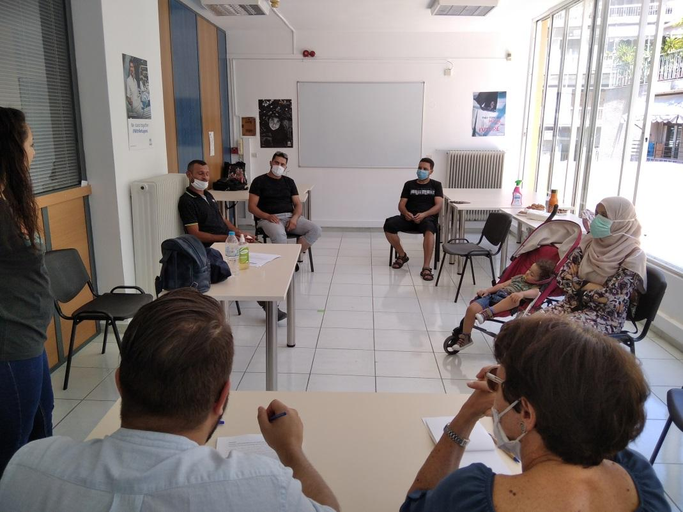
Photo from the third focus group meeting at the Education Committee offices of the Municipality of Athens, Greece
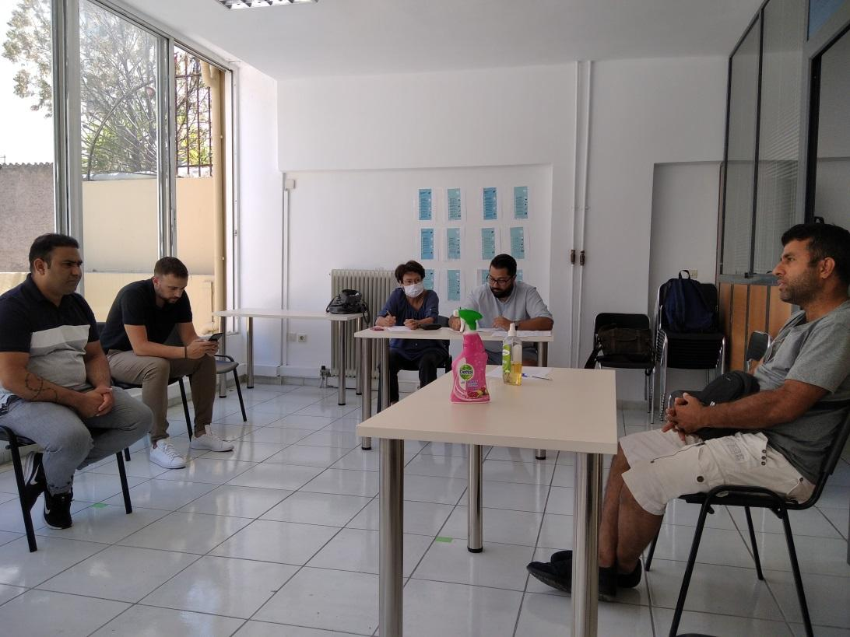

Photo from the third focus group meeting at the Education Committee offices of the Municipality of Athens, Greece

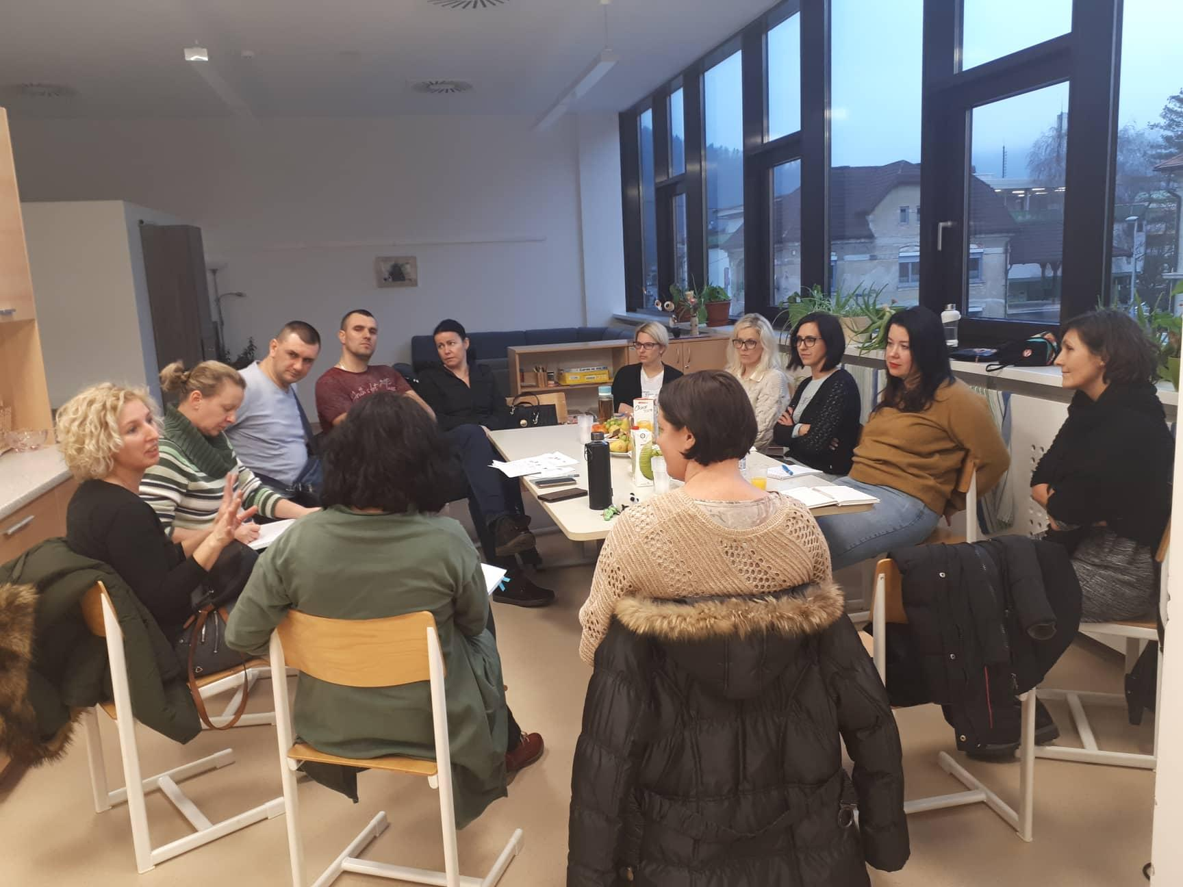
Photo from the focus group meeting at the Primary school of Litija, Slovenia

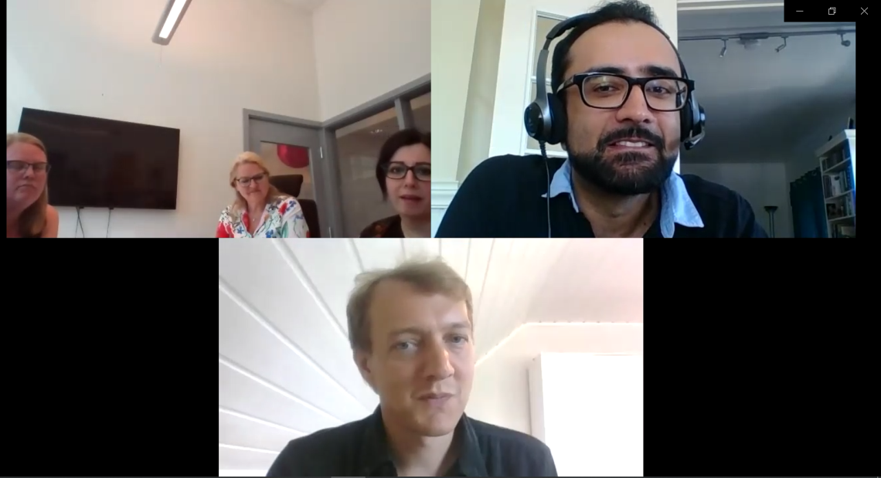
Screenshot from the online focus group meeting in Norway

Conclusion
Overall, the findings of the present report in terms of the national frameworks in place for the integration of the pupils with a M/R background in the four partner countries, the results of the online questionnaire survey among representatives of stakeholder organisations working with the projects’ target group, and the conclusions of the focus group meetings implemented with the participation of immigrant and refugee parents and teachers, emphatically confirm the need for the development of the OpenEYE learning methodology and toolkit as well as its implementation and mainstreaming in formal and non-formal primary education.
In terms of the national frameworks in place for integrating immigrant and refugee children to primary education, common elements have been identified, as well as differences. In all partner countries, children of a M/R background have a right to compulsory free public education, and the competences in the language of the host country is usually the focus of intensive additional teaching offered, as the main criterion for fully integrating to the mainstream primary education. Furthermore, the role of organisations of the civil society and public educational / cultural institutions active in the field is assisting with complementary language courses, psychosocial support or help with homework (Norway), and contributes in keeping pupils in school. The differences between the national frameworks in the four partner countries examined relate to the different models adopted in relation to the school autonomy; while in Italy schools are free to develop their own way of working with pupils with a M/R background, in Norway it is the municipality that selects the model to adopt in schools (partly integrated model or non-integrated model in mainstream schools, or reception schools exclusively for immigrant/refugee pupils). In Slovenia, a recent reform has outlined the main guidelines for schools on how to deal with immigrant/refugee pupils, including the curriculum of the assistance teaching in Slovene and the qualifications of teachers who will carry them out), but the schools retain autonomy on how to form classes (integrated or not) and implement complementary activities targeted at immigrant/refugee children. In Greece, schools follow a central strategy for integrating pupils with a M/R background to education, based on Reception Classes for immigrant/refugee pupils who also attend mainstream school classes.
The survey findings highlight the teachers’ urgent need for training on different approaches for working with / managing multicultural classes, mainly aimed at developing the pupils’ teamwork skills, verbal and non-verbal communication skills, competences in the language of the host country and their safe introduction to the local culture, while they also stress the need for the support of the pupils’ families, the school management and the educational framework.
All the survey participants working with immigrant/refugee pupils (primary school teachers, school leaders, educators and learning facilitators working in civil society or cultural organisations) show a great interest in integrating cultural expressions into their work; this is also the case for the minority of participants who have never before used cultural expressions in their work. The participants recognize the great potential benefits of integrating cultural expressions in their learning activities for the immigrant/refugee pupils as well as for the native pupils (in the case of integrated classes), and consider them effective in the fields of language learning and mental wellbeing, as well as developing social skills, intercultural awareness and an open mentality, also making pupils feel included in the school community and contributing to their social inclusion outside the school environment. Especially with regard to language learning, cultural expressions can help convey the meaning of words or abstract ideas very effectively, and make learning more enjoyable.
Most participants have already used a great variety of forms of cultural expressions in their work, including art, photography, design, music, storytelling, cultural heritage, theatre, literature, films etc., and offer examples of good practice and ideas for employing interesting techniques like “kamishibai” in learning activities. Although the majority of the participants do not think that the use of cultural expressions in learning can have negative impacts, a culturally sensitive approach by the teacher/facilitator is recommended in order to guide the pupils through the complex concept of diversity and avoid negative reactions in the class (e.g. making fun of cultural differences, inappropriate behaviours on sensitive or taboo subjects, etc.).
Using History and Mythology as content for learning activities based on cultural expressions, as proposed in the OpenEYE project, offers great opportunities for introducing universal values and concepts to the pupils, while also raising the pupils’ interest and engagement in the class.
In terms of helpful training or resources in order to integrate or better employ cultural expressions in their work, the survey participants’ preferences vary; while the participants in Greece mostly favour ready-made modules with step by step instructions and theoretical knowledge about cultural expressions in education, the participants in Italy and Slovenia prefer basic learning modules that they can easily modify. However, all participants would appreciate inspirational material like good practice examples and role models and a supportive network.
Based on findings of the present report, the following issues should be taken into account in designing the OpenEYE Learning Methodology:
- The common elements and differences between the national frameworks for integration of immigrant/refugee children in primary education in the partner countries should be reflected in the design of the OpenEYE Learning Methodology, in terms of flexibility and potential for implementation in various settings, formal or non-formal, or with integrated (native and immigrant/refugee pupils together) or non-integrated (immigrant/refugee pupils only) classes.
- The active involvement of parents/families of pupils (both immigrant/refugee and native), as well as the native pupils (in the case of an integrated class) into the learning/integration process is key. Although the involvement of parents, especially immigrants/refugees, in the school activities has posed many difficulties in the past (language barrier, lack of time or interest, negative mentalities, etc.), it is important to recognize their role in the OpenEYE Learning Methodology and propose ways to encourage their participation. Building a solid, two-way communication channel between the school/teachers and the parents is necessary for the pupils’ effective integration into the school community, making the transition between the school and home environments smoother. The OpenEYE Learning Methodology should recognize the wider role of schools as agents of social integration, not limiting to the pupils but including their parents and families as well.
- The OpenEYE Learning Methodology should focus on the learning priorities identified. While the main focus is on language learning (the national language of the host country or a foreign language, e.g. English), the methodology should also focus on creating a safe learning environment for all pupils, developing intercultural awareness and an open mentality, as well as on the development of soft skills (e.g. teamwork, non-verbal communication skills, etc.)
- A wide range of forms of cultural expressions should be employed, in order to capitalize on the experience available already as well as the available resources in different countries and learning settings, and in order to reach a wide range of learning objectives. Examples of integrating different forms of cultural expressions to reach different learning objectives in different learning settings should be available, in order to inspire and encourage teachers.
- The benefits of employing the OpenEYE learning methodology should be clearly outlined, in terms of effectiveness as well as flexibility in different learning settings. This will assist teachers in promoting its implementation and will boost its mainstreaming potential.
- The methodology should include guidelines on how to limit the possibility of negative reactions in the class (e.g. preparation of the class through appropriate introductory activities, indicated reactions by the teacher/facilitator in such an event, etc.)

Appendices

National Survey Reports
To access the national survey reports please click on the respective links below:
Norway – National Survey Report
Greece – National Survey Report
Slovenia – National Survey Report
Italy – National Survey Report

OpenEYE Online Survey Questionnaire

OpenEYE online survey
Addressing teachers & support staff working with pupils of a migrant/refugee background (ages 6-12)

Start Page
Due to the ongoing refugee crisis and migration waves reaching Europe from Asian and African countries, many thousands of migrant and refugee children have reached the EU countries and have, following different processes in each country, managed to enter the host countries’ formal and non-formal educational systems. The educational systems in all receiving countries are often not prepared to integrate these new pupils to the school community and provide a safe learning environment for key skills like language learning.
The “Open Education for Young Europeans through History, Art and Cultural Learning” project (Open EYE) focuses on creating an open learning methodology based on History, Arts and Cultural Learning, as well as the necessary implementation tools, that will enable teachers of primary education in Europe (formal and non-formal) to support their students in language learning and integration in their school and community, in nowadays multilingual and multicultural classrooms.
This survey will help us explore the learning needs of educators who work with pupils of a migrant or refugee background, and the potential offered by history, culture and the arts to develop new methods and tools for supporting them.
Thank you very much for taking the time to answer our questions! The survey results will be freely available at the OpenEYE website: www.erasmusopeneye.eu

Page 01
Page Header: Please tell us a little about yourself and the children you work with.
Question 01
[Multiple Choice; *answer is mandatory]
Please choose the most suitable sector where your engagement with the pupils occurs.
- Primary school education
- Non-governmental organisation offering integration support
- Health and welfare organisation
- Cultural organisation (Museum, Gallery, etc.)
- Religious organisation
- Other: _________________________________________________________

Question 02
[Multiple Choice; * answer is mandatory ]
Which age group of pupils do you work with primarily?
- 6-8 years old
- 8-10 years old
- 10-12 years old
- Other: ______________________________________

Question 03
[Multiple Choice; * answer is mandatory ]
In your classes, what is the percentage of pupils of a migrant/refugee background on average?
- Up to 25%
- 25% - 50%
- 50% - 75%
- 75% +
- I work exclusively with pupils of a migrant/refugee background

Question 04
[Multiple Choice; * answer is mandatory ]
How often do you hold your classes?
- On a weekday basis (i.e. Monday to Friday)
- 3-5 days a week
- 1-2 days a week
- On weekends
- Other (e.g. ad hoc or more rarely than above): _______________________________

Question 05
[Multiple Choice; * answer is NOT mandatory]
What is your primary role in your organization's structure?
- Lead Management (head of organization, school headmaster, project manager, etc.)
- Administrator
- Teacher
- Social worker
- Combination of different roles
- Other: __________________________________________

Question 06
[Multiple Choice; maximum choices: 2; answer is NOT mandatory]
In what role do you work with pupils?
- As a professional educator (salaried member of staff)
- As a volunteer educator
- As temporary education staff
- Both as staff and volunteer
- Other: __________________________________________

Page 02
Page Header: Please let us know of your experience in working in multicultural classrooms.
Question 07
[Multiple Choice; * answer is mandatory ]
Did your initial training include teaching/supporting multicultural classes?
- Yes
- No

Question 08
[Matrix; * answer is mandatory]
Have you received subsequent training in teaching/supporting multicultural classes?
- No
- Yes, a little
- Yes, to some extent
- Yes, a great deal

Question 09
[Multiple Choice; * answer is mandatory ]
Do you think that working in a multicultural class requires a different approach to the one used for a class of native-only pupils?
- Yes
- No

Question 10
[Free Text; * answer is NOT mandatory]
If No, please explain why.

Question 11
[Multiple Choice; * answer is mandatory ]
According to your experience, please rate the importance of the following issues in working with a multicultural class (Please rate “1-Not important at all”, “2-Of some importance”, “3-Of great importance”)
- Language difficulties of pupils with a migrant/refugee background
- Conflict between different groups in the class
- Bullying
- Gender issues
- Different levels of ability in the class
- Behaviour issues linked to cultural differences (incl. religion)
- Communication problems between the teacher and the pupils
- Communication problems between the native pupils and the pupils with a migrant/refugee background
- Communication problems between the teacher and the pupils’ family
- Other

Question 12
[Free Text; * answer is NOT mandatory]
If Other, please describe the issue here.

Question 13
[Multiple Choice; * answer is mandatory ]
What are in your opinion the learning priorities for the integration of pupils of a migrant/refugee background to the school community? (Please rate “1-Not important at all”, “2-Of some importance”, “3-Of great importance”)
- Acquiring competences in the native language
- Acquiring competences in English
- Getting safely introduced into the native culture
- Developing verbal and non-verbal communication skills
- Developing teamwork skills
- Developing digital skills
- Other

Question 14
[Free Text; * answer is NOT mandatory]
If Other, please describe the priority here.

Question 15
[Multiple Choice; * answer is mandatory ]
Please rate the importance of the following factors in helping you teach/support a multicultural class (Please rate “1-Not important at all”, “2-Of some importance”, “3-Of great importance”)
- Being trained on relevant learning methodologies
- Access to relevant learning material
- Availability of necessary resources (human and material)
- Support from management
- Support from pupils’ parents/families
- Support of native pupils in the learning process
- Other: __________________________________________

Question 16
[Free Text; * answer is NOT mandatory]
If Other, please describe the factor here.

Question 17
[Multiple Choice; * answer is mandatory ]
How often do you adapt your teaching material and methods to accommodate the multicultural character of the class?
- Never
- Rarely
- Some times
- Often
- Very often

Question 18
[Multiple Choice; * answer is mandatory]
What are the constraints in adapting your teaching material and methods to accommodate the multicultural diversity in the class? (Please rate “1-Not important at all”, “2-Of some importance”, “3-Of great importance”)
- Lack of support from the educational framework (policy, curriculum, management etc.)
- Lack of time
- Lack of relevant learning methodologies/guidelines/resources
- Lack of relevant skills
- Increase in workload
- Other: __________________________________________

Question 19
[Free Text; * answer is NOT mandatory]
If Other, please describe the obstacle here.

Page 03
Page Header: Please let us know whether you have made use of one or more cultural expressions in your work so far with multicultural classes (with “cultural expressions” we mean, for example, cultural heritage, art, music, literature, theater, dance and crafts).
Question 20
[Multiple Choice; * answer is mandatory ]
Do you have experience in using cultural expressions in your work with multicultural classes and pupils of a migrant/refugee background?
- Yes [If the user selects “yes”, he/she will be sent to page 04]
- No [If the user selects “no”, he/she will continue on page 03]

Question 21
[Matrix; * answer is NOT mandatory]
If you don’t use cultural expressions in your work with multicultural classes, to what extent do the reasons given below play a role?
*Plays a huge role / Plays a role to some extent / Plays no role
- I don't know enough about what is a cultural expression
- I don't know enough about how to use cultural expressions
- I am personally not interested in cultural expressions
- I'm not encouraged to use them in my organization
- I don't have enough time and resources in my organization to use such methods
- I don't think they are relevant to my teaching

Question 22
[Free Text; * answer is NOT mandatory]
Please specify other reasons for not using cultural expressions in your work with multicultural classes.

Question 23
[Multiple Choice; * answer is mandatory]
Would you be interested in using cultural expressions in your work in the future?
- Yes [If the user selects “yes”, he/she will continue on page 05]
- No [If the user selects “no”, the survey is over]

Page 04
Question 24
[Multiple Choice; maximum choices: 9; * answer is NOT mandatory ]
Please indicate which cultural expressions you have used in your work with pupils of a migrant/refugee background.
- Music
- Dance
- Theater
- Art, photography and design
- Crafts
- Film
- Storytelling
- Literature
- Cultural heritage (objects, documents, exhibitions, historical sites, buildings)
- Other: _____________________

Question 25
[Free Text; * answer is NOT mandatory]
Please give examples of themes and activities related to cultural expressions that you have worked with.

Page 05
Question 26
[Matrix;* answer is NOT mandatory]
In what way do you think that learning through cultural expressions can help the pupils of a migrant/refugee background? Please rate* the statements below.
(*Please rate “1-Not at all”, “2-To some extent”, “3-A great deal”)

Cultural expressions can ...
... help them to feel more at home in their new country
... help them develop self-esteem
... ease their integration into the school community
… ease their transition from the family environment to the school environment and vice versa
... make learning easier
... make learning a new language easier
... help them to compensate for a lack of basic skills and competences
... help them to discover cultural similarities
... help them to express difficult emotions
... encourage them to be active in classes
... increase their motivation to engage in school activities
... increase their happiness and well-being
... help them to develop an understanding of the culture of their new country

Question 27
[Matrix;* answer is NOT mandatory]
How do you think that cultural expressions can help the native pupils in a multicultural/diverse class? Please rate* the statements below.
(*Please rate “1-Not at all”, “2-To some extent”, “3-A great deal”)
Cultural expressions can ...
... help them to connect with their fellow pupils
... make learning easier
... help them to discover cultural similarities
... help them to express difficult emotions
... encourage them to be active in classes
... increase their motivation to engage in school activities
... increase their happiness and well-being
... help them to develop an understanding of different cultures and intercultural awareness

Question 28
[Multiple Choice; * answer is NOT mandatory ]
Do you think that the use of cultural expressions in learning can have a negative impact on teaching/supporting a multicultural class?
- No
- Yes
If your answer was yes, please explain why, and how you think these negative impacts can be avoided.

Question 29
[Matrix; * answer is NOT mandatory]
To what extent could cultural expressions be used to support pupils of a migrant/refugee background in their learning and development?*
(*Please rate “1-Not at all”, “2-To some extent”, “3-A great deal”)
- Language learning
- Basic skills training
- Mental well-being
- Overall performance in school

Question 30
[Free Text; answer is NOT mandatory]
Which other areas of refugee training and support do you think could benefit from the use of cultural expressions?

Question 31
[Free Text; * answer is NOT mandatory]
How could your work benefit from using cultural expressions?

Question 32
[Matrix; * answer is NOT mandatory]
What would you find helpful* in order to implement or better employ cultural expressions in your work as an educator?
(*Please rate “1-Not at all helpful”, “2-To some extent helpful”, “3-Very helpful”)
- A mentor program
- A supportive network of people
- A training course I can attend in person
- An online training course
- Hands-on training
- More theoretical knowledge about cultural expressions
- Inspirational material (good examples, role models)
- Ready-made modules with step-by-step instructions
- Basic teaching modules that I can easily modify
- Training on how to communicate the importance of using cultural expressions
- Support from the management of my organization

Question 33
[Free Text; answer is NOT mandatory]
What else can help you to (better) use cultural expressions in your work as an educator?
Last Page
Finish message
Thank you very much for completing this survey!

OpenEYE focus group questions outline

Context: The objective of the focus group meeting(s) to be implemented in each partner country is to gather qualitative information regarding the learning needs of the primary target group of pupils of a migrant/refugee background, the attitudes and interests of the pupils’ parents and teachers (as immediate learning stakeholders) towards employing a culture-sensitive learning methodology based on history/mythology and employing cultural expressions (i.e. drawing, music, dance, singing, handicraft, etc.), and their role in this learning process.
The focus group(s) will be held with the participation of parents/guardians and teachers who will be invited to attend at the local school or other educational premises (i.e. museum), following the stakeholders survey. The local project partners are expected to act as facilitators. The focus group will take the form of a relaxed and inclusive informal discussion, where both teachers and parents are invited to share their views as immediate learning stakeholders. A simple language should be used to compensate for lack in language skills; interpretation services should be used if necessary. The questions outlined below serve to guide the discussion and do not have to be strictly followed, as in an interview.
The facilitators, following the focus group(s), are expected to prepare a short report describing the context (i.e. where did the focus group(s) took place, when, who were the participants – an attendance sheet would be helpful), the issues discussed, and the main findings. This report will be integrated to the national report (also including the survey questionnaire results) to be prepared for each partner country.
At the beginning of the focus group the participants should be informed about the project and its objectives, invited to fill in the attendance sheet, and asked for their permission to document the meeting by taking photos or videos that will be published on our website.
Questions:
Question 1: How long have the children been in the host country and how long have they been involved in education?
This question serves to set the context and start the discussion.

Question 2: Are they experiencing problems in integrating into the school community, i.e. following the curriculum, making friends at school, etc.? Are they happy at school? What is their relationship with their fellow pupils?
This question serves to identify the issues of integration.

Question 3: What are in your opinion the learning priorities for them? I.e. acquiring language skills (language of the host country and/or English), being safely introduced into the native culture, developing verbal and non-verbal communication skills, developing digital skills etc.
This question is related to question 13 of our stakeholder survey questionnaire, and aims at getting the response of parents as well as teachers. A dialogue between them could offer valuable insights.

Question 4: Which kinds of cultural expressions do you think they would be interested in? Are they already active in a form of cultural expressions? By cultural expressions we mean for example, cultural heritage, art, music, literature, theater, dance and crafts.
This question serves to map the pupils’ interest in certain types of cultural expressions.

Question 5: What do you think about introducing to the class learning activities based on history/mythology and cultural expressions of different cultures? Do you think it would help the pupils? In what way?
This question is related to question 26 of our stakeholder survey questionnaire, and aims at getting the response of parents as well as teachers. A dialogue between them could offer valuable insights.

Question 6: How would you see your role as parents/teachers in this learning process? How could you contribute?
This question aims at initiating a productive dialogue between parents and teachers, supporting a “learning stakeholder” mentality and reinforcing their collaboration potential in the future.

